Announcement

―My Number System―

The Japanese government adopts “My Number System” and it will begin in January 2016.

“My Number” is the one to one person. It is needed when you go through procedure at

municipal office and so on. So it is very important.

You will receive the following envelope by registered mail from late October.



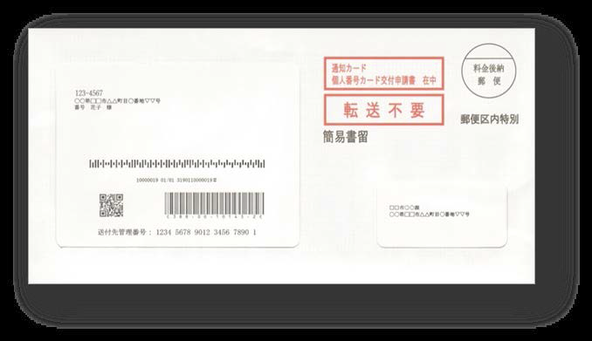

　＜Envelope＞　　　　　　　　　 ＜Notification Card＞

This envelope contains above- mentioned “Notification Card” which is written your “My

Number”. Please keep your “My Number” and “Notification Card” with caution. In order not to



be used your “My Number” illegally, please don’t teach your “My Number” to others without

necessary case.

You can apply “Individual Number Card”. “My Number” is written

in this “Individual Number Card” and you can use it as your ID.

You can get various certificates at convenience store in Japan. ＜Individual Number Card＞

So it is very　convenient. If you don’t receive the letter until this fiscal year, please come to the

International Student Support Section.

Flyer by 25 countries

<http://www.cas.go.jp/jp/seisaku/bangoseido/otherlanguages.html>